**Project 2 – Automated-High-Availability-Website-Deployment-on-AWS**

**Highlights:**

Launch a DB instance in Amazon RDS  
Create an Elastic Beanstalk Environment  
Configure Security Groups and Scaling

**Steps 1:** Create Database > go to RDS > Select Database Engine MySQL > Selected Free tier database> Give the name of DB instance Identifier > Give the Master user name “admin” > give the master password “Admin1234” > Select Connectivity > VPC as same as Webserver > Public access No > Now Create SG where Inbound traffic allowed only from webserver SG > Create Database.

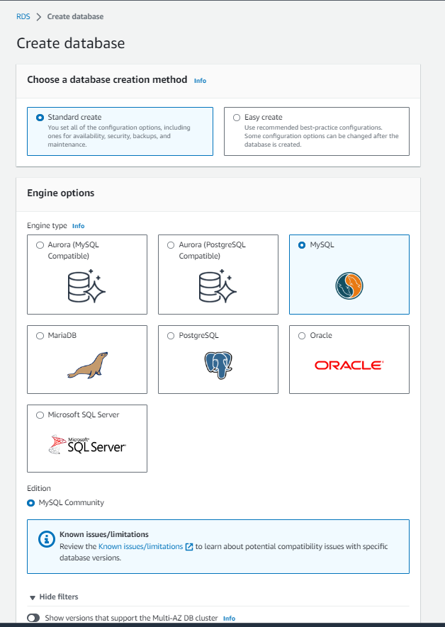

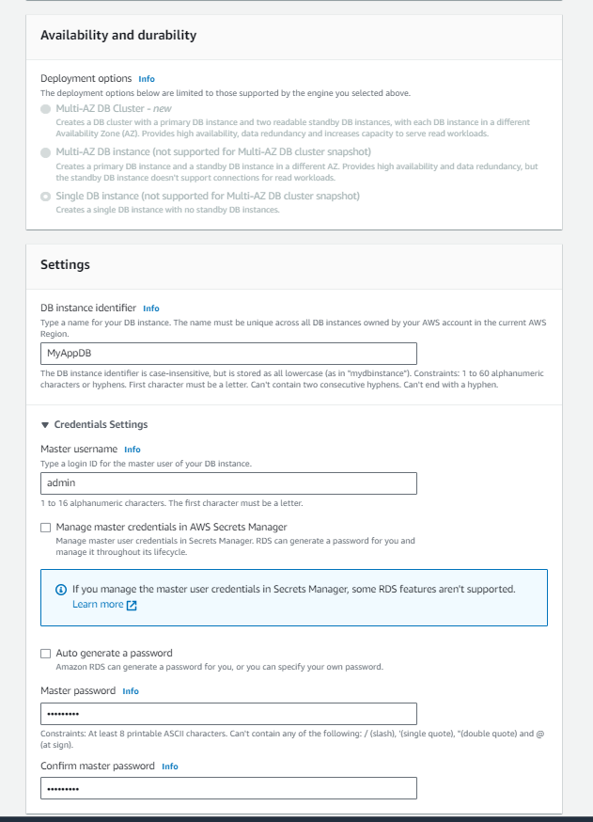

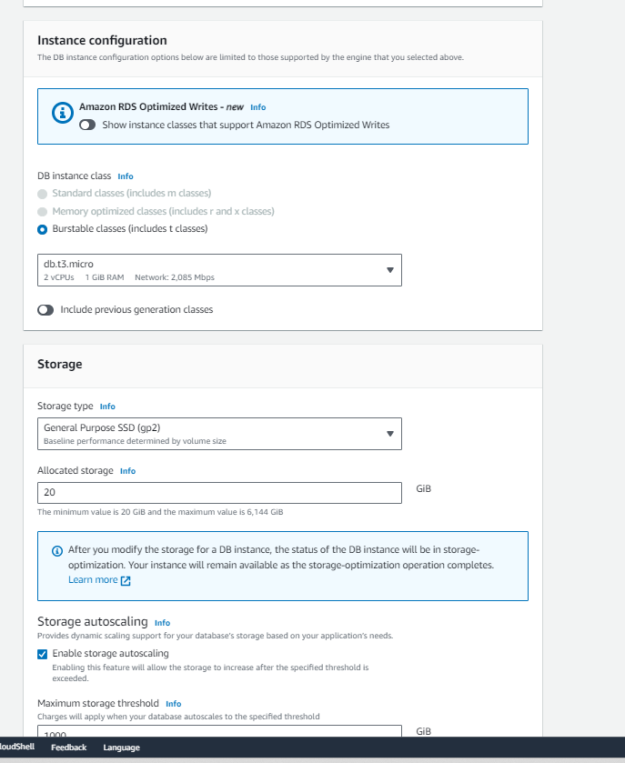

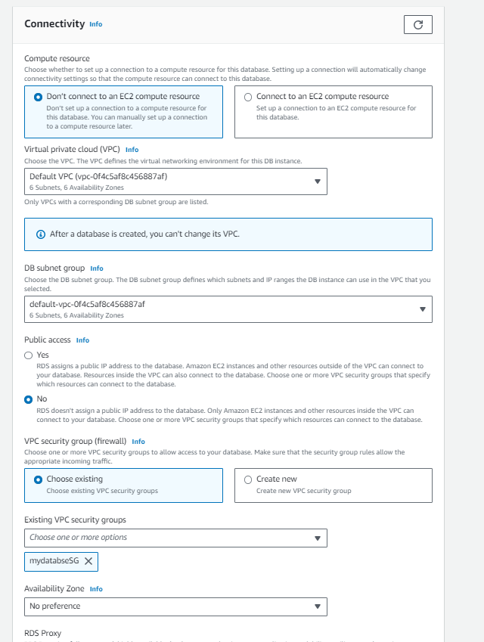

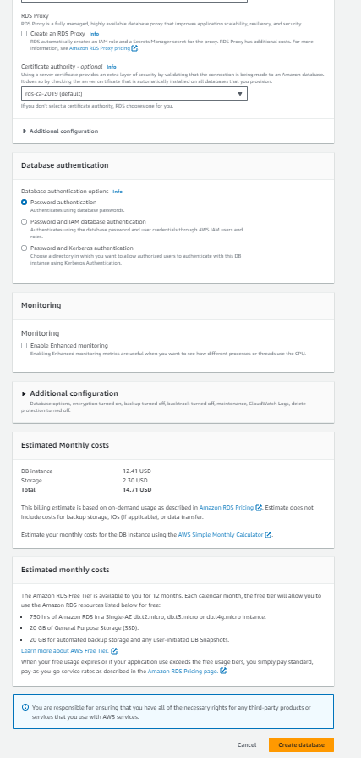

**Steps 2 :**  Go to Elastic beanstalk > Create a application > selected Environment “Webserver Environment” given application name “ Myapp” > selected Platform PHP > choosen application code “sample code” > Preset “ High Availability > Next.

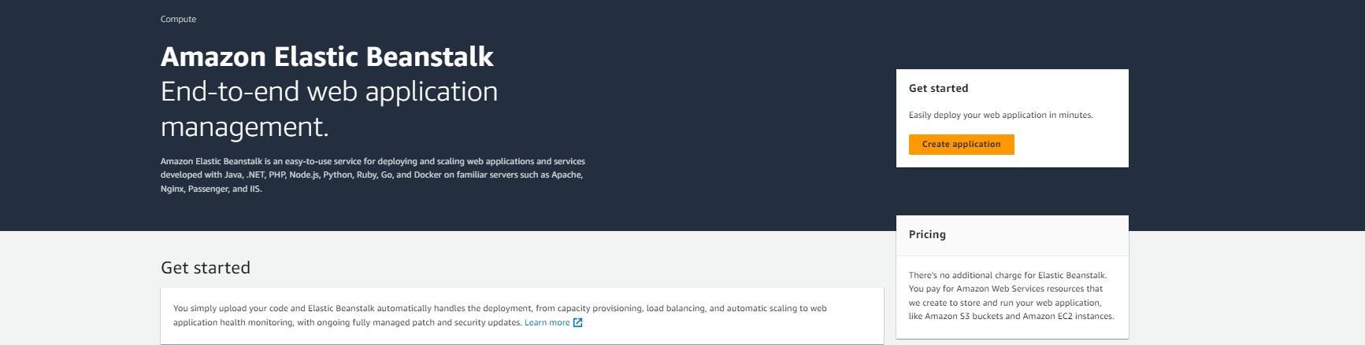

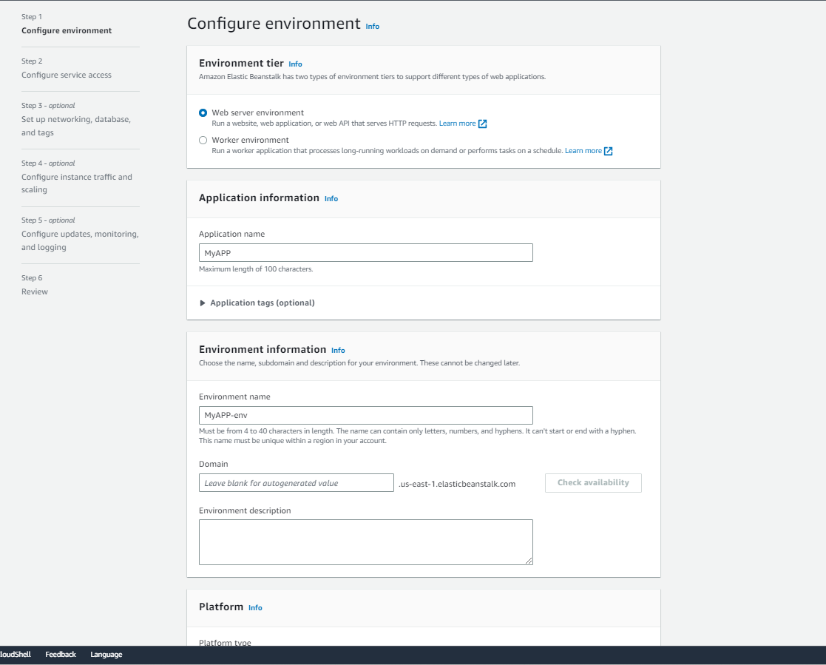

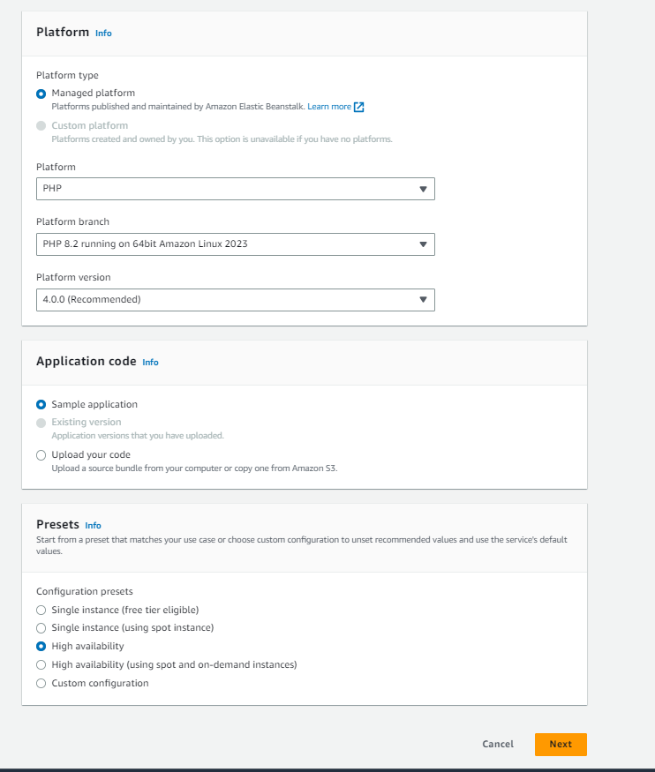

**Setps 3 :**  Now configure Service Access > I have Created Service role so choosing use an existing service role > I have Created Keypair name with “Avi Demo keypair” >I have Created EC2 Instance profile where allowed “EC2 administrator” > Next

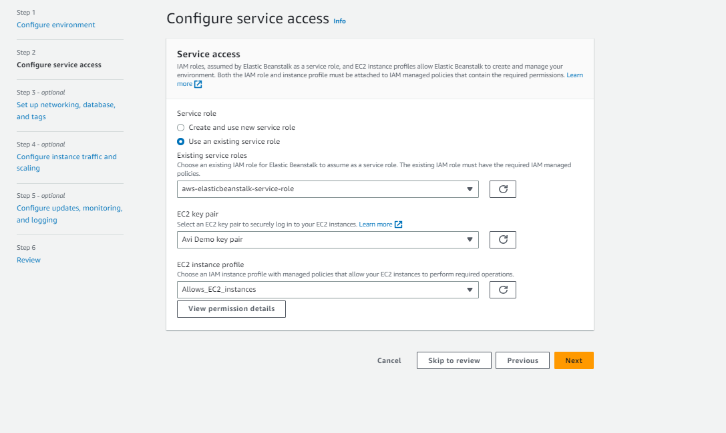

**Steps 4:**  Now Setup Networking > Chooses Default VPC >  Allowed Public Access > Next > Next > Submit.

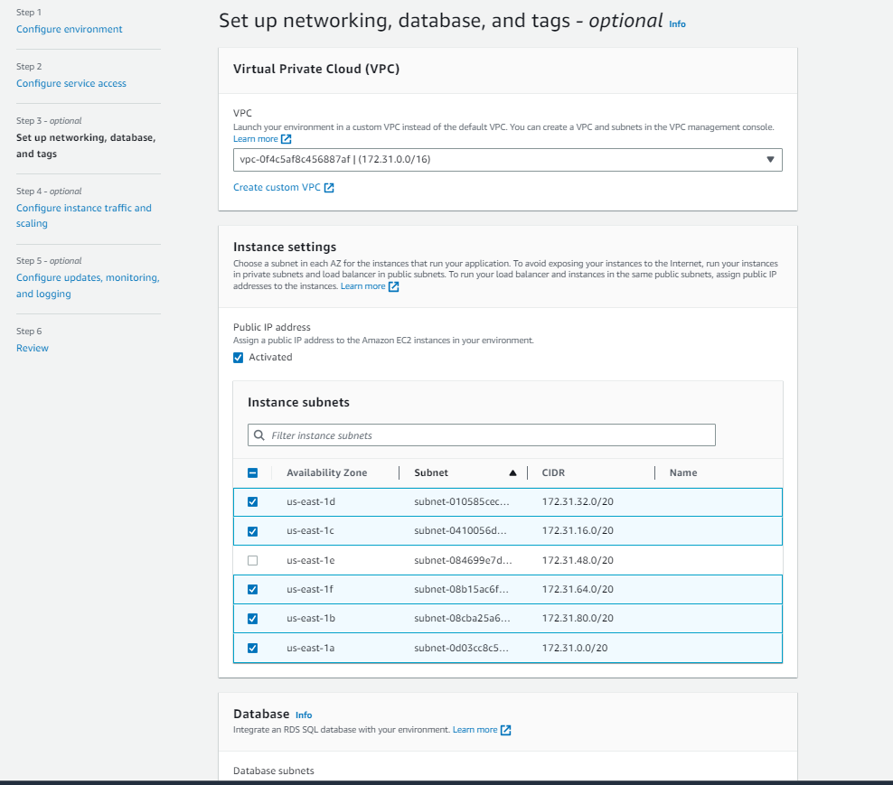

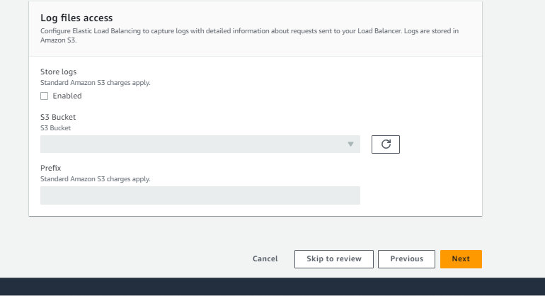



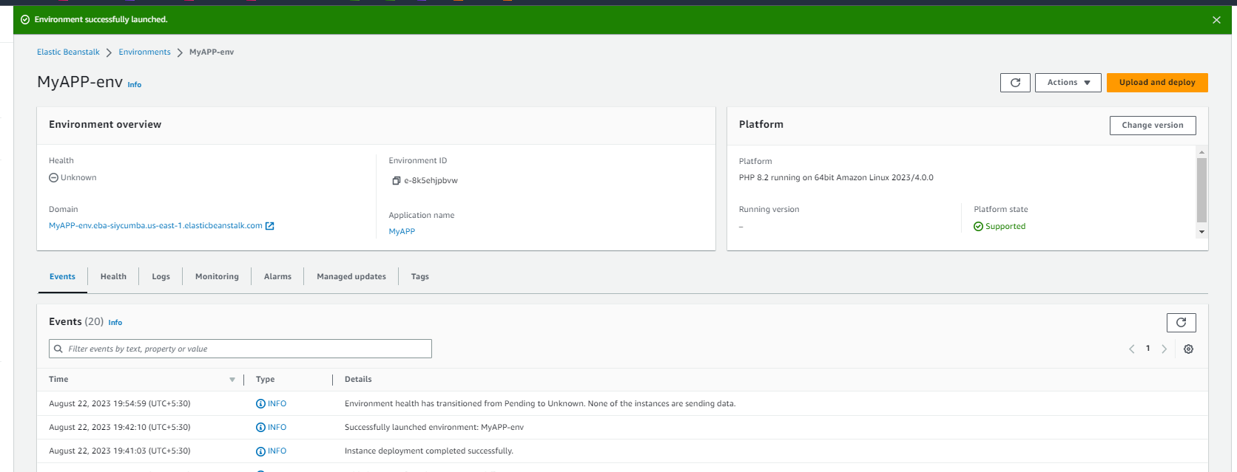

**Steps 5 :**  Now manage Security groups and Scaling

Go to Configuration > Ec2 Security Groups > I have Created already for my webserver where allowed HTTP and SSH for public name with myWebserver SG > Selected it

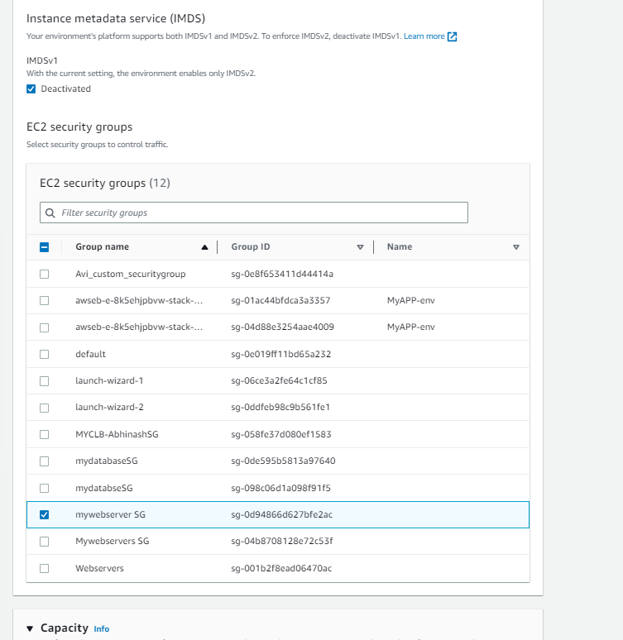

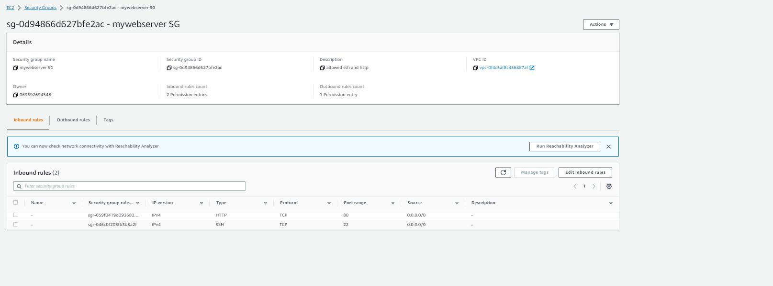

Now manage Auto Scaling Group > Environment type “Load Balanced” > Instances (min -1, max-4) > Instance type t2.micro

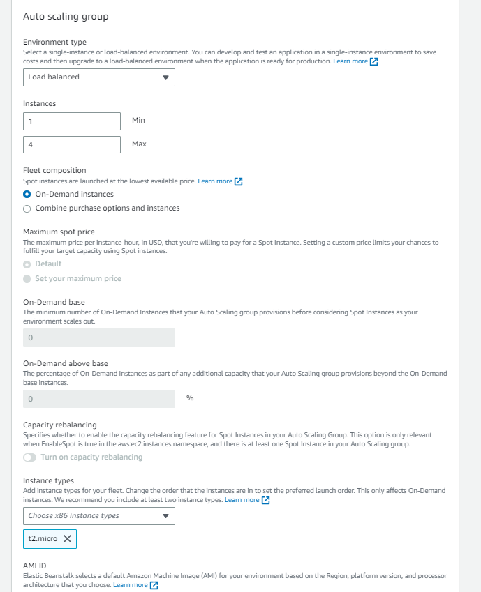

Now select Visibility Public > load balancer subnet “ I have chooses where I want to launch my server”

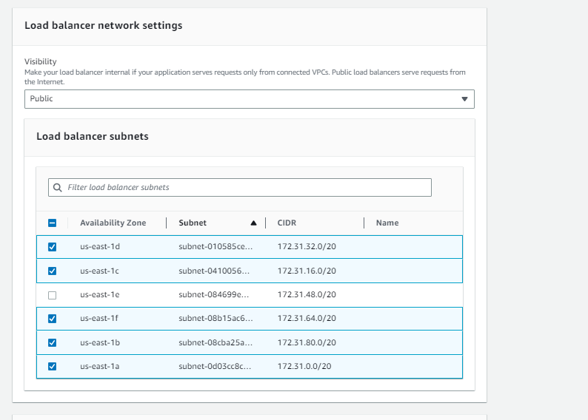

Load Balancer Type > Application Load Balancer > and allowed listener 80 > Apply to save changes

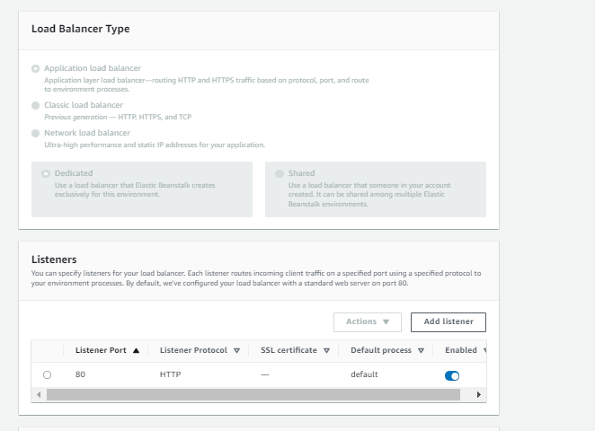

Now go back to Auto Scaling Group > And change SG same as main server where allowed HTTP and SSH > Now Edit Group Detail > change desired Instance “ I have chooses 2” > Submit >> Done

